**MAKING OF DARK SENSOR USING BREAD BOARD**

***A MINOR PROJECT REPORT***

*Submitted by*

D. Srihari (171FA05078)

M. Sai Kishore(171FA05305)

R.V.L. Karthik (171FA05329)

**in**

**Electronics and Communication Engineering**

*Under the Esteemed Guidance of*

*Assistant professor-SUNIL RATHORE*



(ACCREDITED BY **NAAC** WITH **‘A’** GRADE)

MHRD **NIRF 88**RANK

**DEPARTMENT OF**

**ELECTRONICS & COMMUNICATION ENGINEERING**

**VFSTR, VADLAMUDI**

**GUNTUR-522213, ANDHRADESH, INDIA**

**November 2018**

**CERTIFICATE**

This is to certify that the minor project report entitled **MAKING OF DARK SENSOR USING BREAD BOARD** that is being submitted by Srihari, Sai Kishore, Karthikbearing Regd. No. 171FA05078,171FA05305, 171FA05329in partial fulfilment for the award of II year I semester B.Tech degree in Electronics and Communication Engineering to Vignan’s Foundation for Science Technology and Research, is a record of work carried out by him/her under the guidance of SUNIL RATHORE of ECE Department.

Signature of the faculty guide Signature of Head of the Department

Mr. Sunil Rathore Mr.T.Pitchaiah M.E,MIEEE

Asst.Professor Assoc.Professor

**TABLE OF CONTENTS:**

**Table of contents**

|  |  |
| --- | --- |
| **Contents** | **Page.no:** |
| Abstract | 4 |
| Introduction | 5 |
| Components Required | 6 |
| Gate Description | 7 |
| Circuit Diagram | 8 |
| Truth Table | 8 |
| Working | 10 |
| Procedure | 11 |
| Hardware Output | 12 |
| Applications | 14 |
| Conclusion | 15 |
| References | 16 |

**TABLE OF FIGURES:**

|  |  |  |
| --- | --- | --- |
| **Sl.NO** | **FIGURE NAME** | **PAGE.NO** |
| 1 | Working circuit | 8 |
| 2 | Circuit diagram | 9 |
| 3 | Transistor | 10 |
| 4 | LED | 11 |
| 5 | Battery | 11 |
| 6 | Resistor | 11 |
| 7 | LDR | 12 |
| 8 | Hardware o/p | 13 |

**ABSTRACT:**  
The circuit presented here is a project of a dark sensor using a light dependent resistor on bread board. LDRs are particularly convenient electronics components to use. They provide large change in resistance for changes in light levels. In the view of their low cost, ease of manufacture, and ease of use LDRs here been used in variety of different applications. At one time LDRs were used in photographic light meters, and even now they are still used in a variety of applications where it is necessary to detect light levels. We can use dark or light sensor in street lights and we the light sensor can give the robot vision and make it easier for it to operate.

**Introduction:**

Dark Sensor (Light Sensor / Automatic Street Light) ... it automatically switches OFF lights when Sunlight fall on it (e.g. in morning), by using a sensor called LDR (Light Dependent Resistor) which senses the light just like our eyes.

it is a simple and powerful concept, which uses transistor (BC 547 NPN) as a switch to switch ON and OFF the street light system automatically.

It automatically switches ON lights when the sunlight goes below the visible region of our eyes. (e.g. in evening after Sunset).

it automatically switches OFF lights when Sunlight fall on it (e.g. in morning), by using a sensor called LDR (Light Dependent Resistor) which senses the light.

The dark sensor circuit described here stops the musical sound when darkness is detected like when you put your hand above the sensor. This circuit can be used as morning alarm. Install it on your window so when the light falls on it will start giving you melodious sound to wake up. In night you can use it to switch off the light of staircase. When you switch off the light of your room with little modification like you can connect relay at output (in place of speaker) to off the bulb. This circuit can be operated with pencil cell as it require less only 3V for its operation. It can easily be mounted because of number of components used in circuit are quite small.

**DESCRIPTION:**

This dark sensor circuit explains the principle of operation of LDR (light dependence resistor). LDR is a device whose sensitivity depends upon the intensity of light falling on it. The resistance of LDR decreases when intensity of light falling on it increases and vice versa (resistance increases when intensity of light falling on it decreases). In dark or in absence of light, LDR exhibits a resistance in the range of mega ohms which decreases to few hundred ohms in presence of bright light.

This phenomenon can be measure with the help of multi-meter. For measuring keep your multi-meter in ohm or resistor measurement region. When you cover the LDR its resistance will be very high and when you place it in light it decreases. We are utilizing this property of LDR to act as a sensor, since a varying voltage drop can be obtained with varying light. In this circuit amount of light is vary because of the shadow of the visitor falls on LDR. So care should be taken while mounting the LDR.

**DESIGN:**

**RESISTOR:**

A resistor is an electrical component that limits or regulates the flow of electrical current in an electronic circuit. Resistors can also be used to provide a specific voltage for an active device such as a transistor. Resistors can also be used to provide a specific voltage for an active device such as a transistor

Here we are using type of resistor is:

|  |  |
| --- | --- |
| Value | 100k, 330R |
| Type | 4 Band Colour Code System |
| Colour Code | Brown, Black, yellow, Gold  Orange, orange, brown, gold |
| Multiplier | Yellow, 10000  Brown,10 |
| Tolerance | Gold Band ±5% |

330r

Here the led glows because

100k the output at the end of the

voltage divider circuit is less

V=0.09v than 0.7v, so here the

r transistor acts as open

switch.

Figure.1. working circuit

**Circuit diagram:**

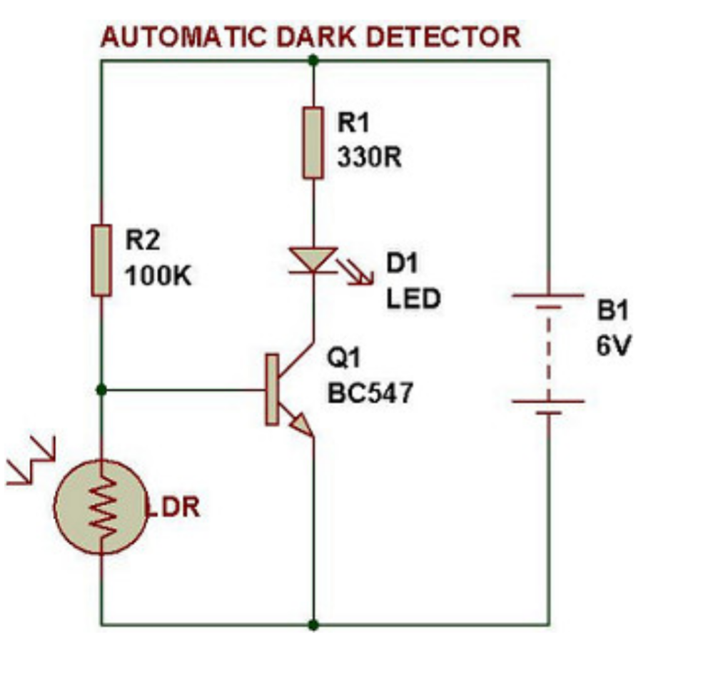

FIG.2.CIRCUIT DIAGRAM

**Required components:**

* 1 - BC547 transistors
* 1 – 330 ohm resistor
* 1 - 100k ohm resistor
* 1 - Colour led
* 1 - 9v battery + battery clip
* 1- light dependent resistor
* Breadboard
* Connecting Wires

**Description of the components:**

* **Transistor**: A BC547 transistor is a negative-positive-negative (NPN) transistor that is used for many purposes. Like all other NPN transistors, this type has an emitter terminal, a base or control terminal, and a collector terminal. It is a medium gain, general-purpose transistor purposely for signal generation, audio amplifiers applications and low power consumptions. Usually the frequency is about 250MHz .

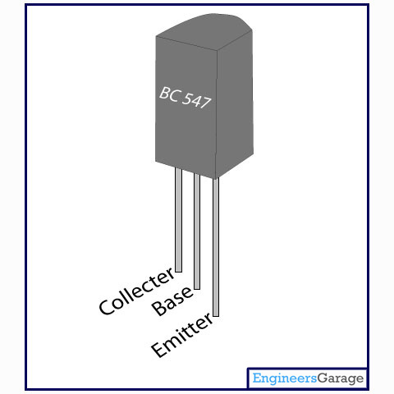

Fig.3.transistor

**LED:**

A light-emitting diode (LED) is a two-lead

semiconductor device that emits visible light when an

electric current passes through it.

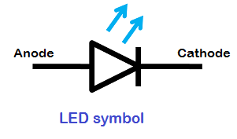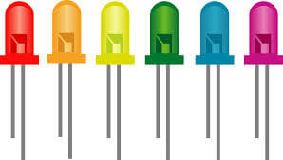

Fig.4.LED

**BATTERY:**

A battery is an electro chemical cell (or enclosed and protected material) that can be charged electrically to provide a static potential for power or released electrical charge when needed. A battery generally consists of an anode, cathode and an electrolyte.

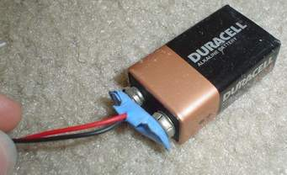

Fig.5.Battery

RESISTOR:

A resistor is an electrical component that limits or regulates the flow of electrical current in an electronic circuit. Resistors can also be used to provide a specific voltage for an active device such as a transistor. Resistors can also be used to provide a specific voltage for an active device such as a transistor.

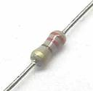

Fig.6.resistor

**Light dependent resistor:**

A photoresistor is a light-controlled variable resistor. The resistance of a photoresistor decreases with increasing incident light intensity; in other words, it exhibits photoconductivity. A photoresistor can be applied in light-sensitive detector circuits, and light-activated and dark-activated switching circuits.

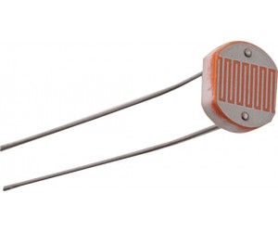

Fig.7.LDR

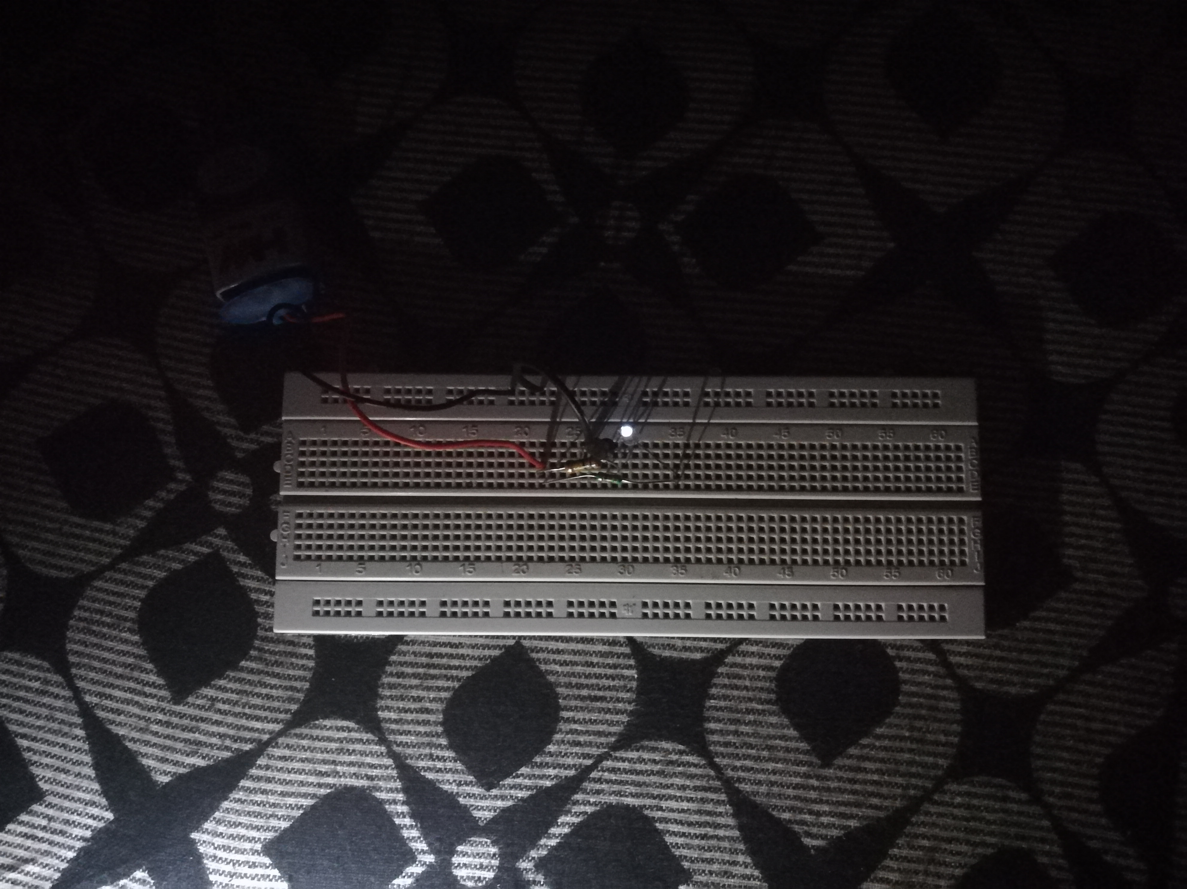**Output of our project:**

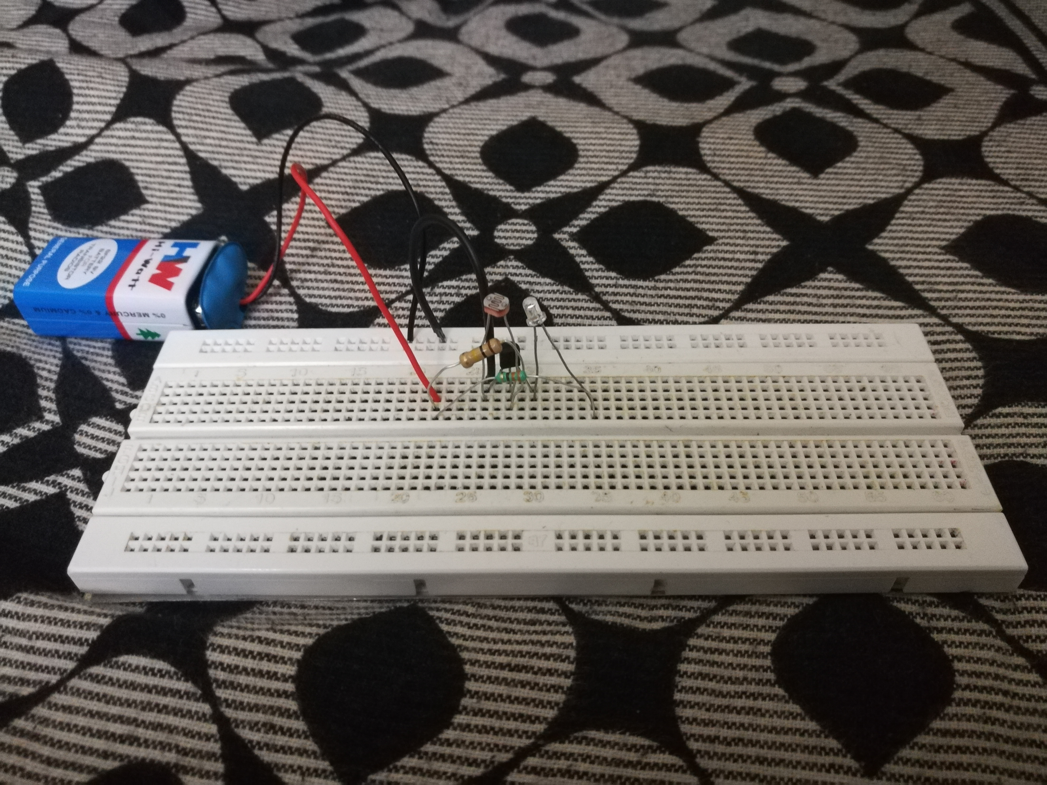

Fig.8.Hardware output



Datasheet of Transistor BC 547

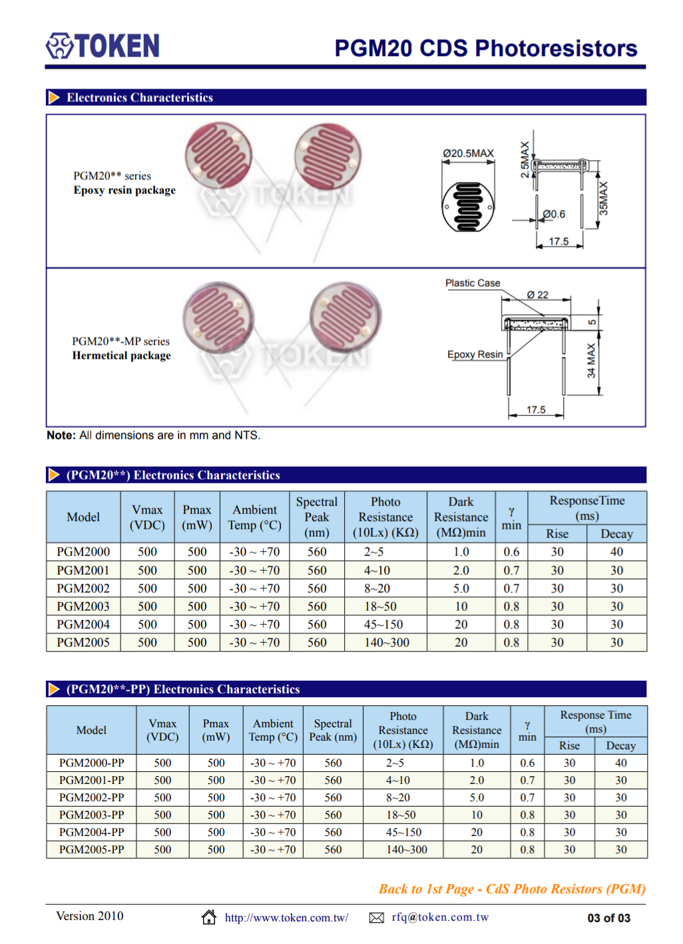

Data sheet of LDR



Data sheet for LED

**Advantages:**

It is a very basic darkness detector with very simple hardware components and circuit.

There is no need for any complex microcontroller circuit or programming to implement this project.

**Disadvantages:**

Since the system is not controlled by any microcontroller, the results might not be as accurate as expected.

**Applications:**

This project can be implemented in applications like automatic switching on of lights when it becomes dark.

This circuit can be part of a bigger circuit or project like home automation or home security system.

**Conclusion:**

Generally, the dark sensor (i.e., light dependent resistor) is used in automatic light depending circuits. When the sun light increases the lights will glow off, if sunlight increases the lights will glow on. The main part of this circuit is light dependent resistor whose ohmic value is depends upon the intensity of light and a transistor which acts like a switching device. It will be used in automatic street lights, intensity of street lights also controlled, Burglar alarm circuits, control and adjusting the brightness of TV and computer screen, etc., It reduces the human power to control lights at nights.

It's simple and basic design makes us easy to design the circuit. The components required for this design also cheaper and it is available for everyone.